Product Catalog | SD card connector
Card Connection Type | Push-pull eject
Card Type | MicroSD card(TF card)
Connector Type | Card socket
Maximum Body Height | -
Contact Material | -
Contact Plating | -
Operating Temperature Range | -
Maximum Soldering Temperature | -
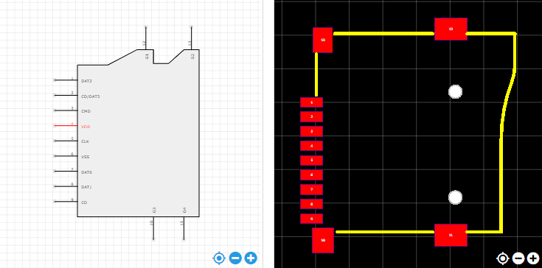
https://item.szlcsc.com/112422.html

